Task 4
Planning Processes

Equipment for principle photography

- JVC digital cameras (4)
- Tripods (4)
- Shotgun Mics (2)
- HDTV
- Nintendo Wii (4 controllers included)
- Xbox 360 (2 controllers included)
- Game capture Card
- Laptop

Job Roles

Matthew Mooney
I was the presenter of the show, so I had to inform the audience as to what is happening during the beginning of the show. During the filming of the show I kept a tally of the scored and made sure everything was working fine behind the camera.
- Presenter
- Floor Manager

Connor McCallion
I was involved with the setup of the cameras and tripods for the multicam show. I also helped set up the game consoles with the HDTV to ensure everything was working fine before filming.
- Camera operator
- Contestant

Ciaran McIlhinney
My role in the game show was the equipment manager sound and lighting and I was starring in the game show as a competitor. The thing that I had to do in the job role was to make sure the cameras sound and light was good and that the shutter speed on the camera matches the TV settings.
- Camera Operator
- Contestant

Christopher O’Neill
For this project I had multiple roles, the main one being production manager, I had to organize when we should book out the studio for filming as well as book out the equipment for filming, I helped with setting up the cameras and tripods as well as help set up the background with the posters which I owned.
- Camera Operator
- Contestant
- Production Manager

Michael Gomersall
The Wii u and Xbox 360 that we used for the production belonged to my brother so I was responsible for bring in that equipment for filming. I volunteered to do the editing for the game show, this is a very time-consuming process as we shot nearly 2 and half hours worth of footage that we need to shorten down.
- Contestant
- Editor

Conversion of Word Scripts to Shot List
We had a strong idea as to how we were going to film this game show because of the rehearsals that we did before principle photography, we had an idea of a 3 camera set up in which we would be able to cover 3 of the angles of the contestants, one being the master which shows all 4 contestants, the other 2 shots being medium shots of 2 of the contestants on both sides, we added in an extra camera to film the gameplay after we had problems with the game capture card, we were able to hid this camera however with the use of posters as background decoration. The only other camera we used was for the green screen, which only had two camera shots, a medium close-up of the presenter and wide shots of the contestants introducing themselves.
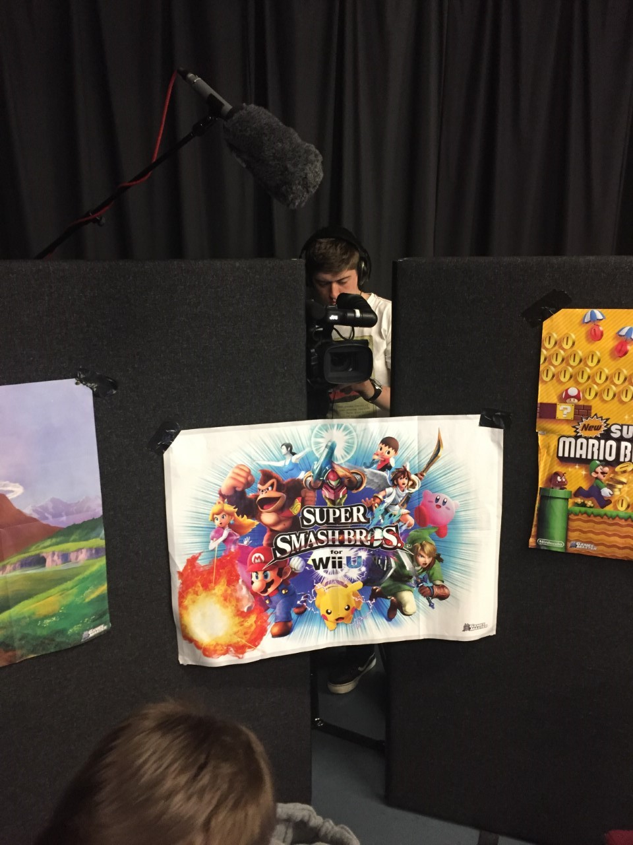

Shotlist

Shot number | Scene number | Location | Shot type | Description | Lighting/Angle
1 | 1 | External studio | Medium Close-up | Presenter introducing the show | Brightly Lit/Normal Angle
2 | 1 | External Studio | Wide shot | Contestants introducing themselves | Brightly Lit/ Normal Angle
3 | 2 | External Studio | Wide Shot  (Master Shot) | Wide shot of contestants | Brightly Lit/High Angle
4 | 2 | External studio | Medium shot | Medium shot showing 2 contestants | Brightly lit/ Normal Angle
5 | 2 | External Studio | Close-up | Camera capturing game footage | Brightly Lit/ Normal Angle

Lighting
We didn’t want any dramatic lighting for the show, we wanted it to be brightly lit, the studio lights were very good for brightening up the show, one of the biggest problems was the green screen as the green screen has to be brightly lit without any shadows as this would negatively effect the quality of effect on the green screen.
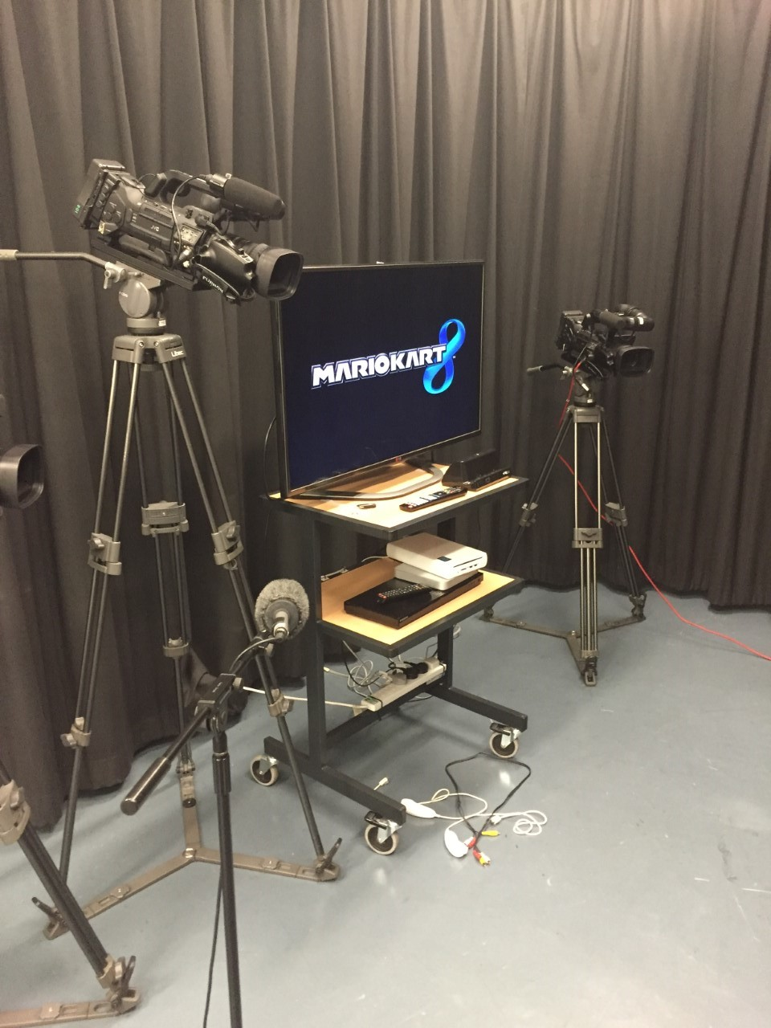

Set
Our ideas for the set were limited by how we could hid the cameras from frame, we came up with the idea of putting up 2 walls in the background and joining them be posters, this was done so that we could hid the camera as well as the tripod which was filming the gameplay off of the screen, we also placed the master camera at a high angle so we couldn’t see that camera.

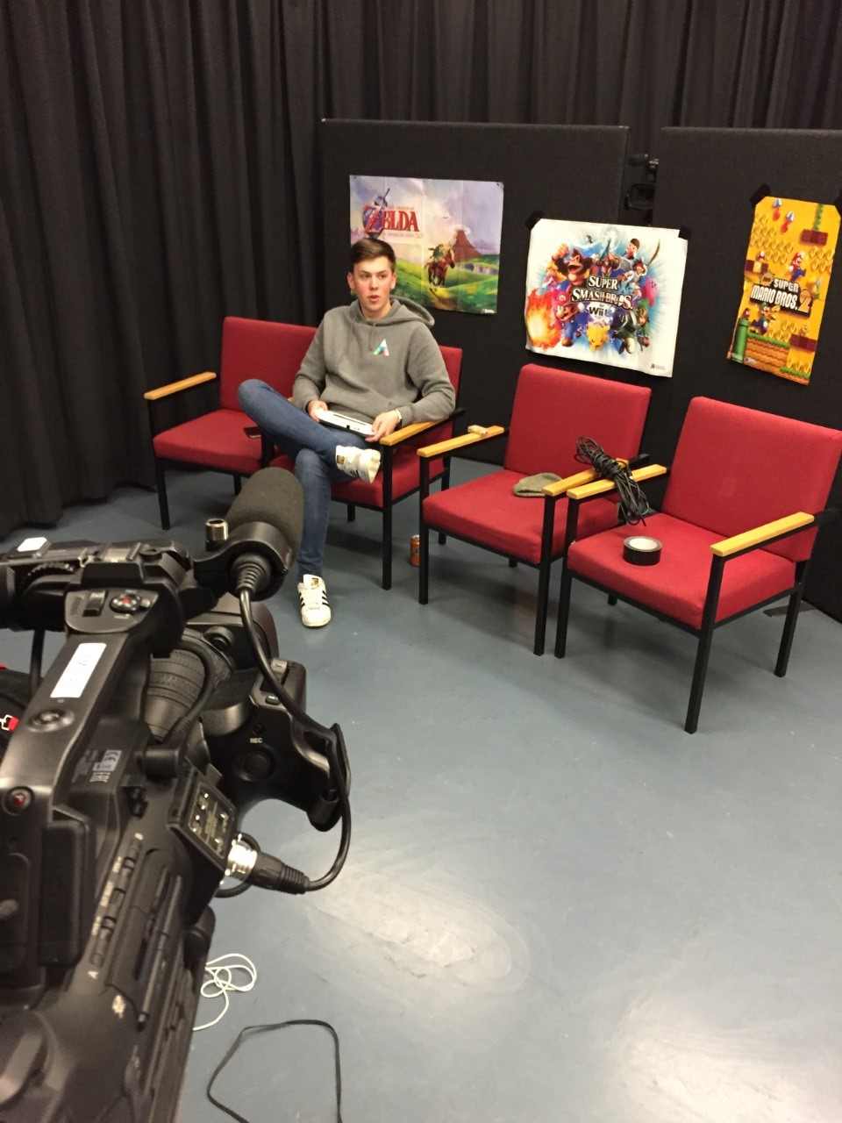

Sound
We decided to use 2 shotgun mics to record the sound in case one of the microphones was dodgy and produced poor audio, we had all 4 cameras pick up sound even though it was of poor audio, this was because we needed to synch the audio for the multicam edit on final cut pro, without this the footage from the other cameras would be out of sync with the good audio’s camera. In terms of sound we wanted to capture the contestants voices over the sounds from the game. We want to see how the edit turns out before we add any non-diegetic sounds as well as music.

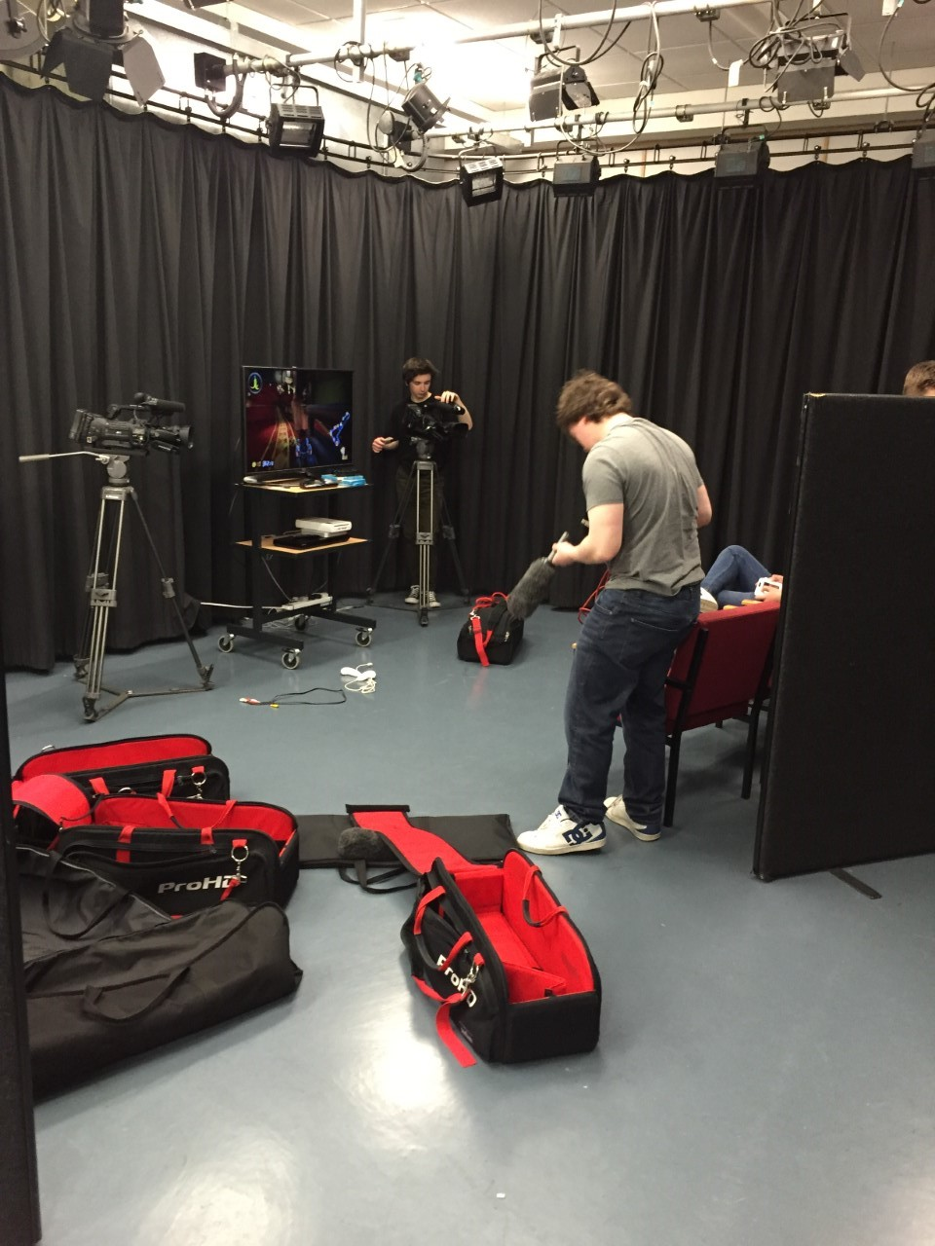

Graphics
Whenever we were brainstorming we didn’t cover the idea of what types of graphics we would use for our production, we would use graphics to inform the audience as to what the scores are and what game is being played. We would also use transitions for cuts.

Health And Safety
In terms of health and safety the biggest threat on set was wires, there were multiple wires for equipment on the set so it was important that we ensured that no one tripped, we did this by tapping down most parts of the wire onto the floor. Since we were in a studio we had to be aware of the fire exits in case of emergency, since we were in a internal filming location and we weren’t doing anything too dangerous health and safety was kept at a minimum during production.

