Unit 34 TV Studio Production Ciaran McElhinney

In this essay I will compare three different types of TV multi camera productions and discuss their genre characteristics. I will consider and analyse aspects of each programme such as narrative structure: content; sequences; pace; flow; continuity as well as look at the technical characteristics of each of these programmes.

The three television productions that I have chosen to use in my essay are Top Gear by BBC, Pointless by BBC and Better Call Saul by AMC. These three shows range in different genres and budgets.

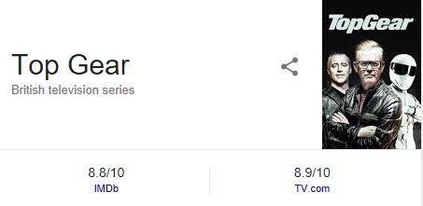 | Broadcaster - BBC Two  Showing time - early evening  Viewers - 6M (s21 e01)(2013)  Budget - 500k per episode (2013)  Genre - Comedy, Talk show
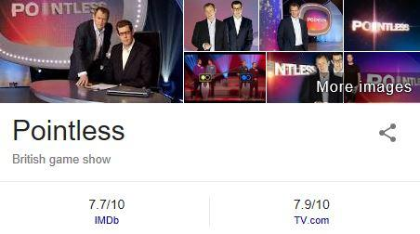 | Broadcaster - BBC One  Showing times - afternoon  Viewers - 3.2m average  Budget - low budget unpublished  Genre - Game show
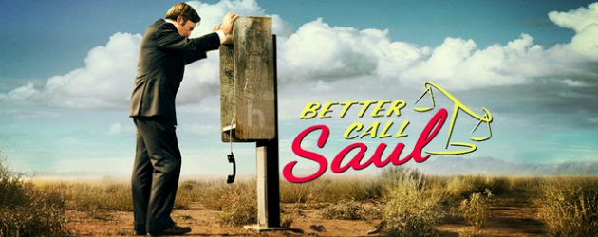 | Broadcaster - AMC  Showing times - late evening  Viewers - 4.3m average season 2  Budget- 1.5 million dollars average  Genre - Drama

This is a Comedy talk show that uses humor as a driving force of the show to interact with the audience. The television programme is well-known to people as the motorshow that that’s full of madness with the odd celeb’s through in to race around their test track.

“The BBC Top Gear show is the best car show in the world” says the ranker.com site and the online voting board proves it.
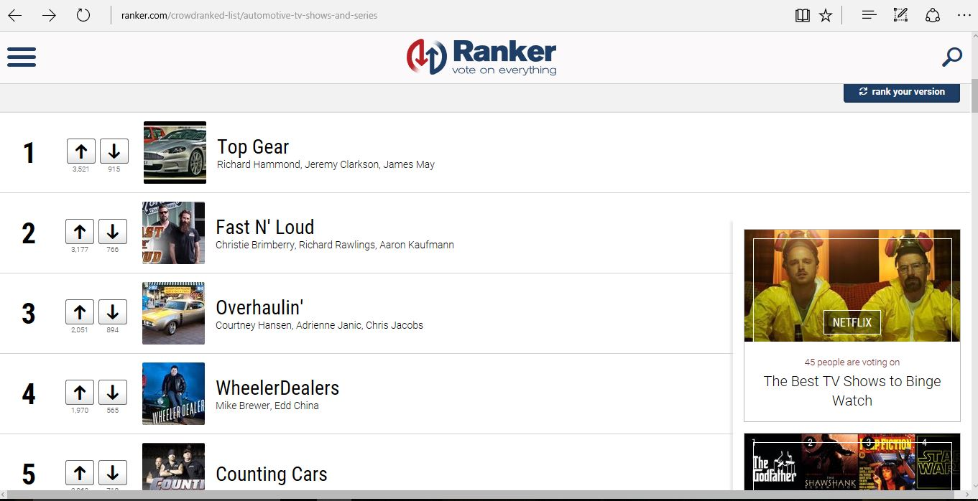

This comedy - talk show first hit our screens way back in 1977 as a half hour motoring show. The original format ran for 24 years and then was transformed into an upbeat revamped format which aired in 2002. Mainly formed around the exuberant persona of Jeremy Clarkson and his off-beat co-presenters Richard Hammond and James May. They subsequently added a twist to the show in 2003 with the one and only - The Stig, a helmeted motor-racing character whose identity was never revealed to the audience. But in 2015 the trio controversially left from the show. With Jeremy getting fired the other two co-presenters refused to work for the BBC show without their friend and colleague with them so they packed their bags and left. This caused the BBC to panic! In 2016 so they would not lose their huge audience and fan base they had to find new presenters quite quickly for the new season and because of the loss of Jeremy they added an extra 200k to the budget making the show’s budget a staggering 650k. They hired new presenter Chris Evans and a lot of co-presenters to fill the space and tried to meet the audience expectations. However, after a disastrous start and critical reviews from the outset the pressure got to them and caused Chris Evans to step down as the main presenter. The show is presented in front of a studio audience and includes a number of different types of presentation. There is usually an introduction, discussion and information provided by the presenter group and short pre-recorded sequences on location. There will be a celebrity guest interview and a short pre-recorded film of this celebrity taking part in an activity, usually test-driving a vehicle or racing. In the first few series, they featured novelty challenges and short stunt films, typically based on location in absurd premises, such as a bus jumping over motorcycles (as opposed to the more typical scenario of a motorcycle jumping over buses) or a nun driving a monster truck. No stunt films appeared between series seven and ten, but series eleven saw the introduction of segments with an anonymous stunt man (credited as "Top Gear Stunt Man") performing car jumps.

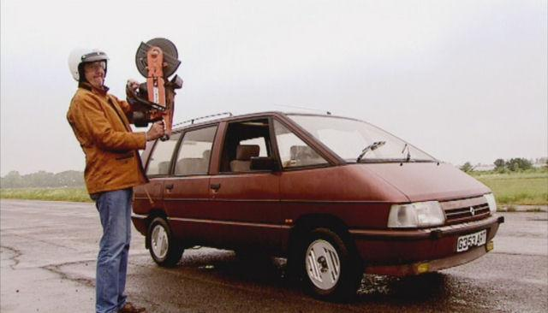
Starting with series five, many of the programme's challenges were introduced with the tag-line "How hard can it be?". These included challenges where the presenters attempt to build a convertible Renault Espace, being roadies for The Who, driving amphibious cars to France, participating in the Britcar 24-hour endurance race at Silverstone Circuit and trying to build an Electric Vehicle that would be cheaper than a G-Wiz.

Starting with series four, one episode of each series has featured a film built around the premise of "cheap cars", whereby the presenters are given a budget (typically around £1,500, but it has been between £100 and £10,000 depending on the type of car) to buy a used car conforming to certain criteria. Once purchased, the presenters compete against each other in a series of challenges to establish who has bought the best car. The presenters have no prior knowledge of what the tests will be, although they typically involve long journeys to evaluate the car's reliability and fuel economy, and a race track event to determine performance.

Many of the car creations from the challenges are on display at World of Top Gear at the National Motor Museum, Beaulieu.

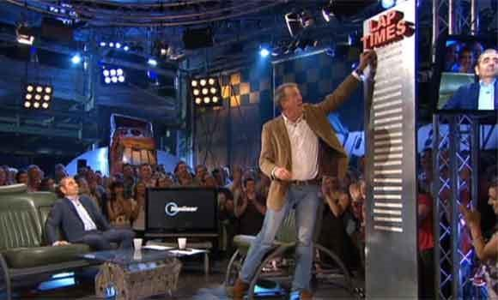
A ‘Star in a Reasonably Priced Car’ is a recurring segment featured throughout the first twenty-two series of the programme. In each episode, a celebrity is interviewed by Clarkson. Then, they and the studio audience watch footage of the guest's fastest lap around the Top Gear test track. The times are recorded on a leader board.
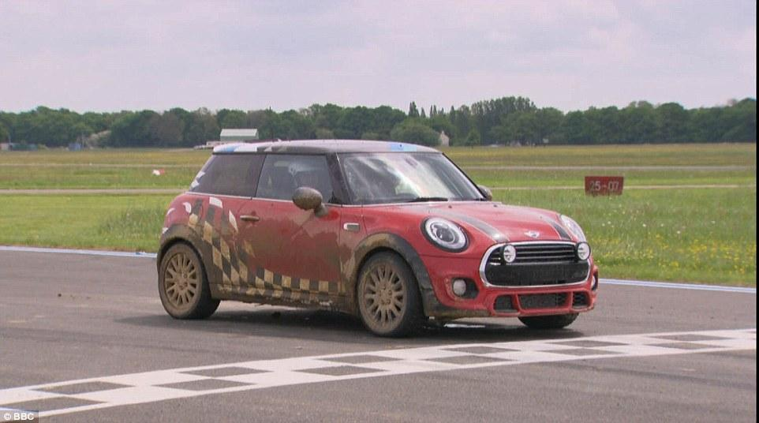
In series twenty-three, the Star in a Reasonably Priced Car was replaced by a new segment, titled Star in a Rally-Cross Car. During the segment, Chris Evans interviews two celebrities, discussing subjects such as their favourite cars and their first cars. The celebrities then complete a lap of the Top Gear track in a rally-spec Mini Cooper. Much like its predecessor, this challenge utilises corners such as The Hammerhead and Gambon, as well as off-road sections, including a "jump", and several deep puddles.

The final section of the show reviews the content of that episode and includes leaders for the next show. There are a number of narrative styles used in this programme, the main presenter will give an introduction often as a voice over for a video sequence of what will be covered in the show. There will be direct delivery to the audience and the main presenter will also ask fellow presenters to give their opinions and comments during the programme. Audience questions and answer sequences are included and guest interviews are also included. There are high quality pre-recorded sequences which often capture high action racing or product trials as well as studio recording with a number of cameras to capture audiences and record interview sequences.

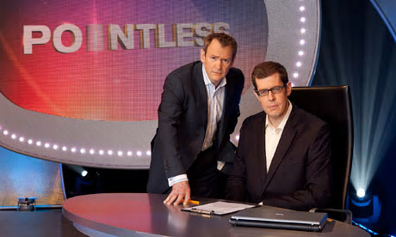
The BBC “Pointless” show is one of the most popular daytime TV game shows at the moment.
“Game shows have been a distinct genre for decades, starting with radio quiz shows and evolving into spectacular prime time extravaganzas. In 2000 a new format, reality television, came along and blurred the lines somewhat. So what exactly is a game show by modern standards, and how do they differ from reality shows?”

The show is aired at about 5pm every day. It has a relatively small budget but still sees their viewing reach between 3 and 4 million viewers each day as they hit a peak viewing time for people finishing work and college etc. With the shows small budget, they film 4 episodes of the show a day to cut the cost of their studio time. The show has a main presenter and an assistant and the guests who take part are on to trying to win the cash prize but to win they have come up with the most obscure answer to get a pointless answer. The presenter on the show is Alexander Armstrong and his assistant is Richard Osman. The contestants on the shows are mostly just your average members of the public who are randomly pick after they run through an online survey to get on the show. There are special celebrity editions from time to time with pretty minor celebrities playing for their chosen charity.

Using a very general outline and understanding that there are and will be exceptions, game shows have the following characteristics in common:
- One or more contestants competing to win a prize, be it cash or other type of prize.
- Some type of game, challenge, or puzzle being played, or a series of similar-themed games.
- Stand-alone, self-contained episodes, with or without a returning champion.
- A regular host.
By today's standards, the most important characteristic that defines a game show is the third one - that each episode is a fresh start with new contestants.

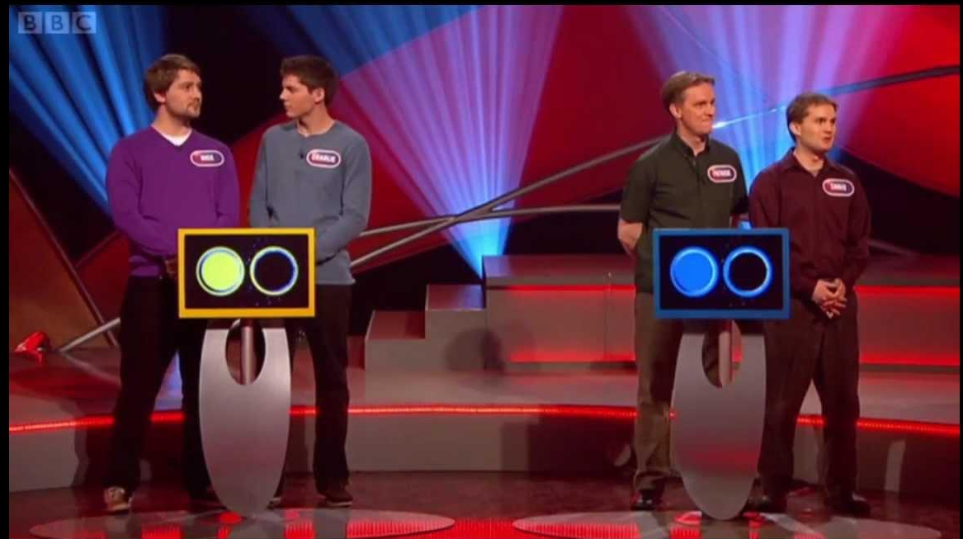
The format and gameplay changed slightly between series. The show starts with the introduction of the contestants, four teams of two, who are asked to introduce themselves - usually stating their name and one or two pieces of information about themselves. The game starts with elimination rounds (three in the first series, two in subsequent series) to whittle the starting line-up down to the two teams who contest the head-to-head; the winning team of the head-to-head plays in the final.

The teams are given a subject, and each team chooses one contestant from their team to answer the question first. Then the question within the subject is revealed. The order of play is determined by drawing lots in advance of recording. Play starts with the person at the podium nearest to Armstrong and ends at the farthest podium; this forms what is known as the "first pass". Then, the contestants at each podium switch to the second contestant, and the order is then reversed for the "second pass". During each of these rounds, teams may not confer.

There are a number of different types of game shows, from tough quizzers to physical competitions. Most game shows fall into at least one of the following categories, and many even incorporate two or more.
- Quiz Shows: Quiz shows are mainly focused on trivia. Examples include Jeopardy! and Are You Smarter Than a 5th Grader.
- Puzzles: Puzzle game shows include word games and other non-trivia puzzles. A perfect example would be Wheel of Fortune.
- Stunt Shows: Stunt-based game shows offer a physical challenge, often made "extreme" or comical. Some examples include Wipeout! and Fear Factor.
- Musical: In a musical game show, contestants are challenged to name songs and/or lyrics, using musical cues. Examples would be Name That Tune and Don't Forget the Lyrics.
- Card and Board Games: Card games and board games can often make for interesting game shows, and there have been many examples of popular games making the jump to television. For example, Trivial Pursuit and The Joker's Wild.

Not every game show will fit into these neat little categories, but all of them offer a distinct form of game play combined with contestants vying to win cash and prizes. The main goal of a game show is to entertain, and most of them are based on the premise that they should be fun, allow viewers to root for the contestants, and offer some kind of play-along factor for the audience.

In Pointless at the end of each round, the team with the highest score is eliminated from the game. In the event of a tie, the tied teams each give an extra answer each until the deadlock is broken and the team with the highest points eliminated. The teams are allowed to confer in the tie-break. In some very rare occasions, Richard Osman may use a substitutional question if both teams cannot name one more correct answer to the specified question. To complete each round, Osman reveals all the pointless answers, or the three least popular if there are no pointless answers, plus the top three answers, which would be worth the highest amount to any contestant. The winners need to achieve at least one pointless answer in the final round to win the jackpot. The jackpot accumulates if it isn’t won and is carried over to the next episode.

Better call saul

Better Call Saul is a crime drama tv show that is aired in America by AMC and also on netflix after each show is released on tv first. The show is set in the Albuquerque, New Mexico in 2002, Better Call Saul follows the story of small-time lawyer James Morgan "Jimmy" McGill it is a spin off from the great TV show “Breaking Bad” but is set six year before he appears on Breaking Bad. In the show they play out the mad day to day events he has to deal with as a lawyer and his include event in his personal life also.

Alesandra Stanley of The New York Times wrote, "Better Call Saul is better than good: It's delightful – in a brutal, darkly comic way, of course."

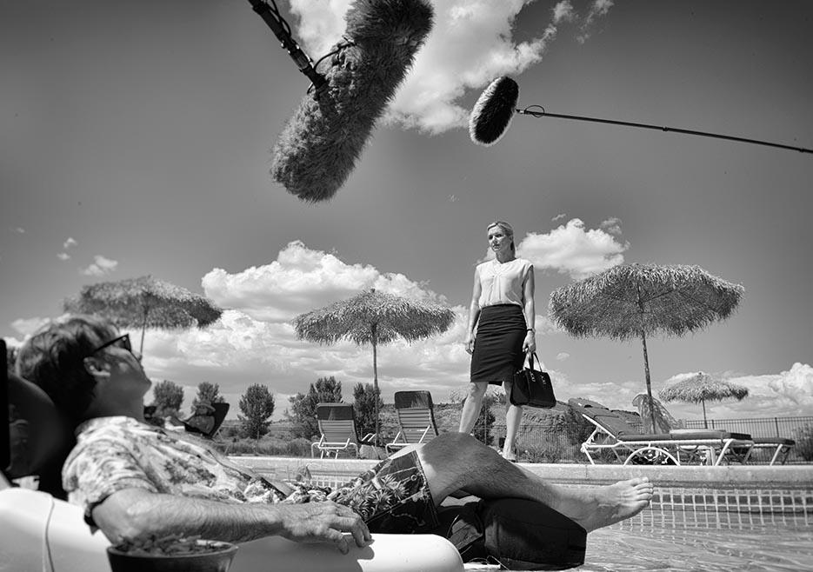
The show is a high budget production and is filmed all on locations as a lot of the show is taking place outdoors and all around the city of Albuquerque. With the show being filmed out and about there's a lot more planning to be done due to the weather and sunlight but as it is filmed in Albuquerque there isn't too much chance of it ever raining.

Spinoffs and franchises have long existed on television. The Mary Tyler Moore Show spawned numerous popular successors in the sitcom world, and the producer Dick Wolf has somehow created not one but two connected law-enforcement universes, first Law & Order and its ilk, and now Chicago Fire and Chicago P.D. That model has been replicated by cop shows like CSI, NCIS, and Criminal Minds, and shows no sign of abatement, but the procedural mystery show has always been easy to copy. Just move it to a new city, hire some name actors, and bingo, a ratings winner. By contrast, what AMC is doing is more complex: finding new paths for its most critically acclaimed programming without sacrificing quality for ratings’ sake. Better Call Saul, the Breaking Bad quasi-prequel that premiered in February, mostly managed to pull it off. While it’s hard to imagine the show ever fully escaping the shadow of its predecessor, it found a funnier, shaggier tone within the Breaking Bad aesthetic, and snagged a slew of Emmy nominations this summer—exactly the kind of recognition AMC wants. More importantly, it got great ratings—nothing like The Walking Dead, but still, an average of 3.2 million viewers for its first season, not far off of Breaking Bad’s last, and more than Mad Men ever got.

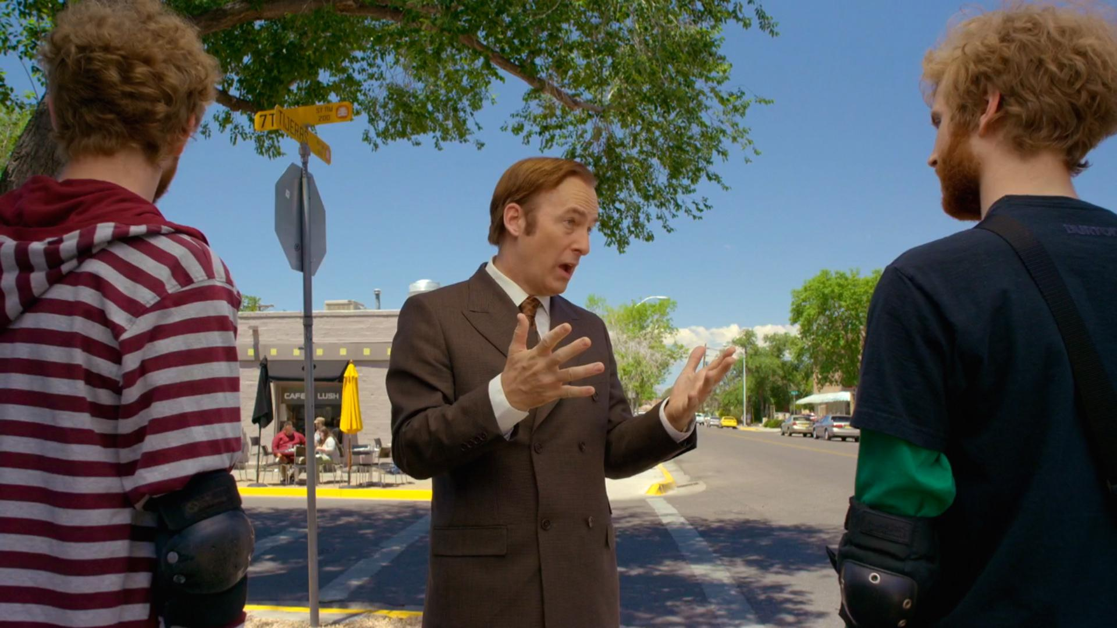
This crime drama has a bit of a nonlinear style of storytelling which that means each episode is laid out like a normal beginning to end story but will take more than one episode to find out the end of the story. The storyline is usually built to last through the whole season and is usually resolved near the end of each season. This form of storytelling can also have flashback to something in the past that may be able to show you why the story is playing out the way it is giving the story a base to grow on earlier events but also can have flash to future event hinting you some details of some big coming near the end of the story like in breaking bad it starts sometimes showing you some shoots that you can not explain at the but you can later in the season . this is also why some of the opening scenes in better call take place in a coffee shop and is shot in black and white to show you the life of Jimmy before he became a lawyer.this helps create a more understanding between the audience and the shows characters and provides a more in depth and emotion to the character in the show.

Bibliography

TopGear:

- http://www.imdb.com/title/tt1628033/fullcredits/
- http://blog.caranddriver.com/how-clarkson-got-himself-fired-and-what-happens-next/
- http://www.dailymail.co.uk/news/article-3475840/Panic-forces-Gear-budget-BBC-lavishing-extra-200-000-episode-bosses-fear-fail.html
- http://www.telegraph.co.uk/tv/2016/06/27/top-gear-ratings-rise-amid-rumours-that-matt-leblanc-may-leave/
- http://www.imdb.com/title/tt1628033/
- http://www.independent.co.uk/arts-entertainment/tv/news/top-gear-records-best-opening-audience-for-three-years-as-6m-viewers-tune-in-for-new-series-9104801.html
- http://www.barb.co.uk/viewing-data/weekly-top-30/

Pointless:

- http://www.digitalspy.com/tv/ratings/news/a457702/pointless-overtakes-the-chase-in-teatime-ratings/
- http://www.imdb.com/title/tt1509677/
- http://www.barb.co.uk/viewing-data/weekly-top-30/
- https://www.thoughtco.com/what-is-a-game-show-1396942

Better Call Saul:

- http://www.tv.com/news/best-of-the-year-the-10-best-dramas-of-2015-144946116297/
- http://www.rollingstone.com/tv/lists/20-best-tv-shows-of-2015-so-far-20150624/better-call-saul-amc-20150624
- https://www.theatlantic.com/entertainment/archive/2015/08/fear-the-walking-dead-is-part-of-cable-tvs-first-premium-franchise/402268/

